|  |  |  |  |  |  |  |  |  |  |  |  |
| --- | --- | --- | --- | --- | --- | --- | --- | --- | --- | --- | --- |
| Link4Life rounded box RochdaleBC_Land_InPartnership  **Application for Arts Organisation**  **Grant Funding Programme**  **2015/16 – 2017/18**  **Information for applicants**  It is the aim of Link4Life that Rochdale Borough is a thriving place in which accessible, quality arts can flourish and participation in the arts is open to everyone. To help achieve this aim Link4Life advises and supports arts organisations to reach their goals in the arts development field.  Link4Life also manages revenue funding from Rochdale Borough Council for constituted arts organisations based in Rochdale Borough.  **Who can apply?**  To ensure appropriate governance is in place it is important that applicants are a properly constituted, not for profit, voluntary arts organisation.  The intention is that organisations use this funding to meet the corporate objectives of Link4Life and Rochdale Borough Council.  **How much can I apply for?**  An upper limit of £20,000, per year, is placed on applications to this grant fund.  Funding agreements will be for a three year period (subject to funding being maintained by Rochdale Borough Council) which will be subject to an annual review.  **How will the application be assessed?**  Applications will be assessed by Link4Life staff led by the Head of Arts & Heritage who will present recommendations to the Board of Trustees of Link4Life. The assessment will include how the proposed activities meet the aims and objectives of the Link4Life Corporate Strategy.  **Timeline for applications**   |  |  | | --- | --- | | Deadline for receipt of applications | **30th September 2014** | | Assessment of applications | **October 2014** | | Report to Link4Life Board/ Approval | **December 2014** | | Arts Organisations informed of funding decision | **December 2014** | | Implementation of New funding arrangements | **April 2015** |   **Advice on applying**  If you require further information please contact:  Julian Jefferson, Head of Arts & Heritage. 01706 924916 [julian.jefferson@link4life.org](mailto:julian.jefferson@link4life.org) |  |

## Part 1 Details of your Organisation

|  |  |
| --- | --- |
| **Organisation Name** | Click here to enter text. |
| **Address** | Click here to enter text. |
| **Postcode** | Click here to enter text. |
| **Daytime telephone:** | Click here to enter text. |
| **Work Phone** | Click here to enter text. |
| **E-Mail Address** | Click here to enter text. |
| **Contact Name** | Click here to enter text. |
| **Position Held** | Click here to enter text. |
| **Contact Address (if different from above)** | Click here to enter text. |

## Part 2 How much are you requesting from the fund?

|  |  |  |  |  |
| --- | --- | --- | --- | --- |
|  | **2015/16** | **2016/17** | **2017/18** | **Total** |
| **Amount of Grant requested** | Click here to enter text. | Click here to enter text. | Click here to enter text. | Click here to enter text. |

## Part 3 Beneficiaries and Impact:

**3.1 What are the activities to be funded?**

**How we will assess.**

When we receive your application we will check whether it is eligible and then consider how the activities delivered by your organisation will have a direct impact on the communities of Rochdale Borough to help Link4Life achieve the aims and objectives of our Corporate Strategy:

**Striving to develop COMMUNITIES that are ACTIVE, CREATIVE and HEALTHY**

Especially:

**People: Supporting people to maximise their own skills and potential**

* Understanding and meeting local need
* Increasing participation, learning and employment opportunities
* Widening access and overcoming barriers
* Targeting resources to priority areas

**Partners: Acting openly and in partnership to achieve shared goals**

**Services: Providing high quality and innovative services**

* Sustaining and enhancing public assets over the long term
* Investing in improvement
* Meeting social and business and environmental objectives that deliver value for money
* Developing the overall leisure and cultural offer

**Quality: Having a culture of high performance and excellence**

* Demonstrating responsible and effective governance and management
* Valuing diversity and inspiring excellence
* Providing outstanding service to customers
* Being an employer that supports and develops its trustees and staff

Please include how you will measure this:

Number of: participants, interventions, volunteers, total number of volunteer hours.

Please also show how you have taken the needs of socially and economically excluded groups (e.g. Black and Minority Ethnic groups, disabled, older people and people on low income) into account and how you will monitor the number of people from these groups.

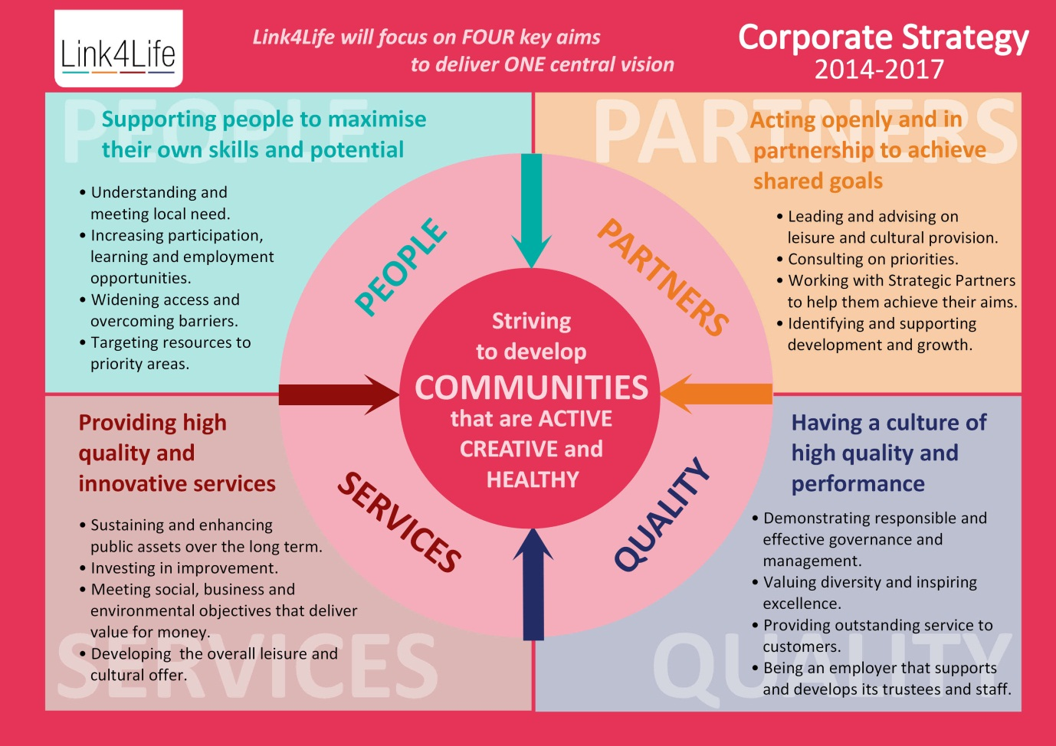

|  |  |
| --- | --- |
| **Description of Activity. Please include what aim (People, Partners, Services, Quality) it links with.**  **Please use additional sheets if required.** | **How Measured**  **including:**  **No. of Participants**  **No. of Interventions** |
| Click here to enter text. | Click here to enter text. |

|  |  |  |
| --- | --- | --- |
| **Participation** | **Total No. of Participants** | Click here to enter text. |
| **Interventions** | **Total No. of Interventions** | Click here to enter text. |
| **Volunteering** | **No. of Volunteers:** | Click here to enter text. |
| **Total No. of Volunteer Hours:** | Click here to enter text. |

## 3.3 Artistic Quality

To ensure best value for money and artistic quality it is essential that organisations are using established creative practitioners in their respective artistic disciplines. Please provide details of how your organisation maintains and develops its creative practice including the selection and verification of artists/facilitators. You are welcome to include references from partners/established practitioners who your organisation has worked with.

|  |
| --- |
| Click here to enter text. |

## 3.4 Examples of Previous Work

Please give evidence of your organisation’s previous work. Please include number of participants/ interventions and length of engagement.

|  |
| --- |
| Click here to enter text. |

## Part 4 Governance Information about your Organisation

### 

### **4.1 Please give names and roles of your Board/Management Committee Members below:**

|  |  |
| --- | --- |
| **Name** | **Role** |
| Click here to enter text. | Click here to enter text. |
| Click here to enter text. | Click here to enter text. |
| Click here to enter text. | Click here to enter text. |
| Click here to enter text. | Click here to enter text. |
| Click here to enter text. | Click here to enter text. |
| Click here to enter text. | Click here to enter text. |
| Click here to enter text. | Click here to enter text. |
| Click here to enter text. | Click here to enter text. |
| Click here to enter text. | Click here to enter text. |
| Click here to enter text. | Click here to enter text. |
| Click here to enter text. | Click here to enter text. |
| Click here to enter text. | Click here to enter text. |

**4.2** Please provide a summary of your organisation including:

Governance – how your organisation is constituted, details of your board, financial probity.

Staffing – information about how many staff your organisation employs, use of freelancers, volunteers etc.

A short summary of what your organisation does.

Please attach separately a statement of accounts for 2013/14.

Please use additional sheets if required.

|  |
| --- |
| Click here to enter text. |

Part 5 Budget

**5.1 Income**

Please state any additional sources of income including in-kind support, revenue from ticket sales or other funding sources. Please state whether this income is confirmed **(C)** or unconfirmed **(UC).**

|  |  |  |  |  |
| --- | --- | --- | --- | --- |
| Income (including VAT if applicable). | Estimated Income 2015/16 | Estimated Income 2016/17 | Estimated Income 2017/18 | **Total** |
| Grant funding sought from fund (Please note the maximum you can apply for is £20,000 per year) | Click here to enter text. | Click here to enter text. | Click here to enter text. | Click here to enter text. |
| Click here to enter text. | Click here to enter text. | Click here to enter text. | Click here to enter text. | Click here to enter text. |
| Click here to enter text. | Click here to enter text. | Click here to enter text. | Click here to enter text. | Click here to enter text. |
| Click here to enter text. | Click here to enter text. | Click here to enter text. | Click here to enter text. | Click here to enter text. |
| Click here to enter text. | Click here to enter text. | Click here to enter text. | Click here to enter text. | Click here to enter text. |
| Click here to enter text. | Click here to enter text. | Click here to enter text. | Click here to enter text. | Click here to enter text. |
| Click here to enter text. | Click here to enter text. | Click here to enter text. | Click here to enter text. | Click here to enter text. |
| **Total Income** | Click here to enter text. | Click here to enter text. | Click here to enter text. | Click here to enter text. |

## 5.2 Expenditure

Please provide a breakdown of your anticipated expenditure for the amount you are requesting from the fund.

|  |  |  |
| --- | --- | --- |
|  | Breakdown of items | Click here to enter text. |
| Salaries | Click here to enter text. | Click here to enter text. |
| Equipment | Click here to enter text. | Click here to enter text. |
| Materials and consumables | Click here to enter text. | Click here to enter text. |
| Travel and subsistence | Click here to enter text. | Click here to enter text. |
| Other | Click here to enter text. | Click here to enter text. |
| Contingency | Click here to enter text. | Click here to enter text. |
| Rent | Click here to enter text. | Click here to enter text. |
| **Total Expenditure** | | Click here to enter text. |

**5.3 Budget Explanatory Notes**: Please use this to detail any explanatory notes to the expenditure and income tables.

|  |
| --- |
| Click here to enter text. |

## Part 6 Declaration

On behalf of the organisation, I confirm that:

* The organisation operates on a non-profit basis and provides arts activities for the benefits of the residents of Rochdale Borough.
* The information given in the application is true and correct.
* I agree to comply with ongoing monitoring and evaluation if my application is successful. (Please note noncompliance may result in the withdrawal of funding.)
* I undertake to inform the Head of Arts & Heritage of any changes in the organisation’s circumstances that would affect this application.

|  |  |
| --- | --- |
| SIGNATURE  on behalf of applicant organisation |  |
| PRINT NAME | Click here to enter text. |
| Date | Click here to enter a date. |

Please note by signing this declaration, you are allowing us to consult with your partners and stakeholders. We reserve the right to ask any applicant to provide additional information or clarification over and above what is submitted in your application as part of our appraisal process.

**Please send completed applications by 30th September 2014 to:**

Julian Jefferson

Head of Arts & Heritage

Arts & Heritage Service

Link4Life

Touchstones Rochdale

The Esplanade

Rochdale

OL16 1AQ